Scientific Insights from SOHO, 2001 -2003

The Solar Interior and Total Irradiance

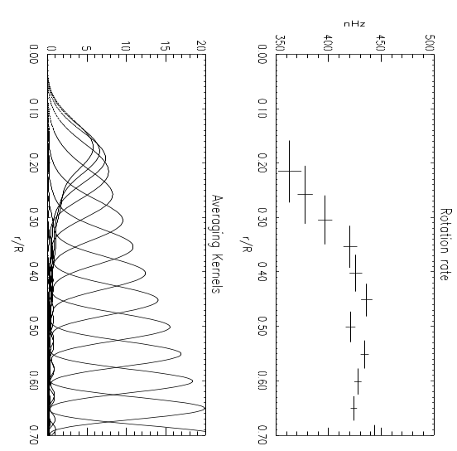
The energy-generating core. The precise determination of thermodynamic properties of the core and its rotation rate is of fundamental importance not only for solar physics but also for the stellar evolution theory and correct interpretation of neutrino experiments. This has been studied by a joint effort of the GOLF and MDI teams. GOLF provides the most precise measurements of the low degree p-modes penetrating into the solar core by using the longest available time series, and MDI measures the intermediate degree modes which allow separating the effects of the core from changes in the outer layer. Using these data, Couvidat et al. (2003) have measured the rotation rate of the core, and found that it rotates slower then the outer part of the radiative zone. This result is unexpected, and can be explained if the angular momentum is transported by internal gravity waves excited by convective overshoot at the base of the solar convection zone (Talon et al, 2002).

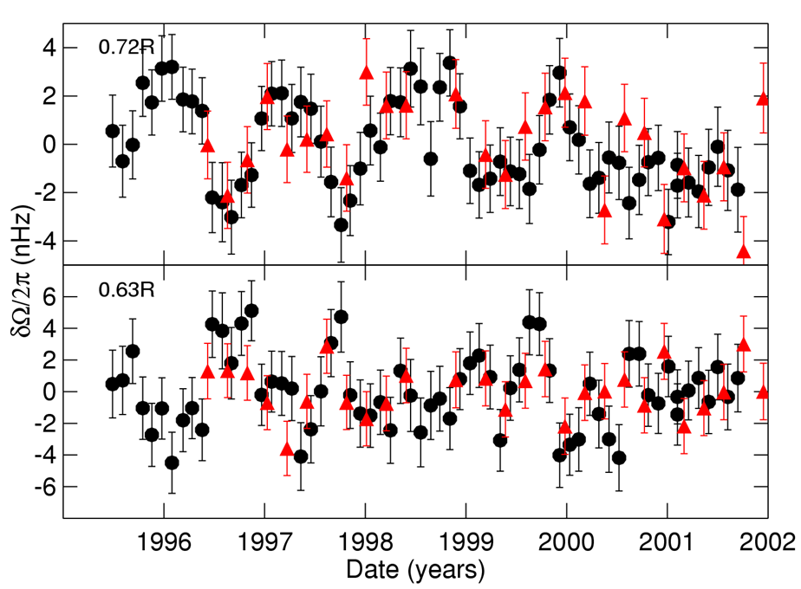
The tachocline. Using MDI data, Howe et al. (2003) have demonstrated that the 1.3-year variations of the rotation rate in the tachocline are persistent through the first half of the solar cycle. It is intriguing that the expected 11-year variation has not been detected. The 1.3-year variations can be explained by a non-linear mechanism of spatiotemporal fragmentation (Covas et al, 2000), and have been detected in the solar activity data by Krivova and Solanki (2002) who suggested that this periodicity can be related to the well-known 156-day period of solar activity. These results indicate that there is the broad range of dynamic time scales of solar variability associated with the surface magnetic activity and magnetic dynamo in the tachocline, and these scales are linked through non-linear interactions. Therefore, one of the SOHO priorities is the investigation of the spectrum of solar variability in the period range of 0.5-11 years.

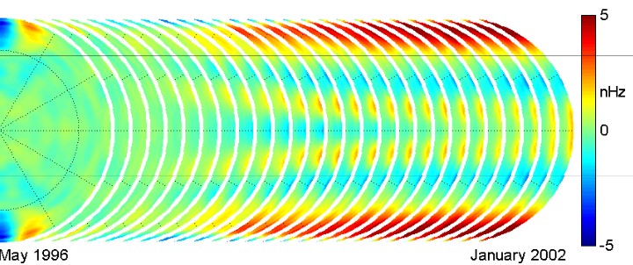
The global circulation of the Sun. Vorontsov et al (2002) applied a novel inversion method to the MDI rotational splitting data of 1996-2002, and found evidence that the zonal shear flows (`torsional oscillation') can penetrate to the bottom of the convection zone. It appears that the entire solar convective is involved in the torsional oscillations, with phase propagating poleward and equatorward from midlatitudes at all depths throughout the convective envelope. This challenges the previous models of torsional oscillations as a secondary effect of migrating sunspot zones. Several methods of local helioseismology have used to measure the meridional flows in the upper convection zone and their changes with the solar cycle. These flows play a key role in the flux-transport dynamo models of the cycle, transporting the magnetic flux in to the polar regions and causing the polarity reversals. The common result is that the meridional circulation slows down when the activity level is higher because of the additional flows converging around active regions in the activity belts (Beck et al; Zhao and Kosovichev, 2003; Haber et al, 2002). In addition, Haber et al (2002) have studied how the meridional circulation varies with depth, and found a surprising evidence of double circulation cells forming during a rising phase of the solar cycle. The complex evolution of the global circulation of the Sun is another challenge for dynamo theories and future observations.

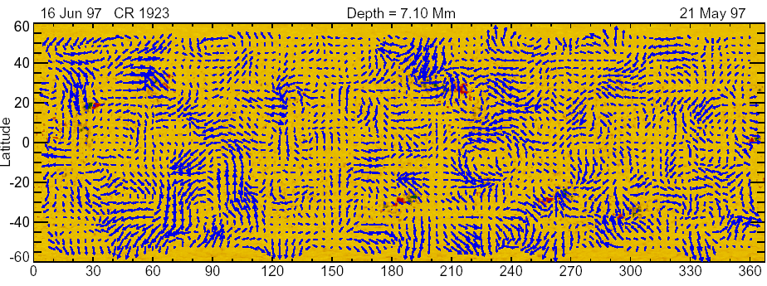
The Solar Subsurface Weather. Analysis of the MDI Dynamics data by methods of local helioseismology has revealed persistent patterns of large-scale flows in the upper convection zone (Gizon and Duvall, 2001; Haber et al, 2002; Zhao and Kosovichev, 2003). These results led to a new concept of the Solar Subsurface Weather (SSW) to the effects of these synoptic flows on the development of solar activity. The initial results are promising, and may result in a new approach to the long-term space weather forecast, based on the dynamics of the upper convection zone.
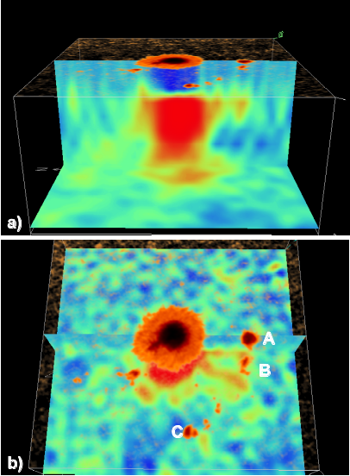
The internal structure and dynamics of sunspots. The high-resolution data from SOHO/MDI have allowed us to investigate the structures and flows beneath sunspots to be investigated in some detail (Kosovichev et al, 2000; Zhao et al. 2003). The results reveal that magnetic connectivity among sunspot structures may exist below the surface, at a depth of 4 Mm. In the Figure showing maps of the sound-speed variations, the large central sunspot is connected to small pores, A and B, which have the same magnetic polarity as the main spot. Pore C of the opposite polarity is not connected. This suggests that sunspots represent a tree-like structure in the upper convection zone. In the typical flow maps at a depth of 0—3 Mm, one can clearly identify a ring of strong downflows around the sunspot, with relatively weaker downflows inside the ring. The flow converges towards the sunspot center. These results are consistent with theoretical ideas of Parker (1979) about the mechanism of sunspots.
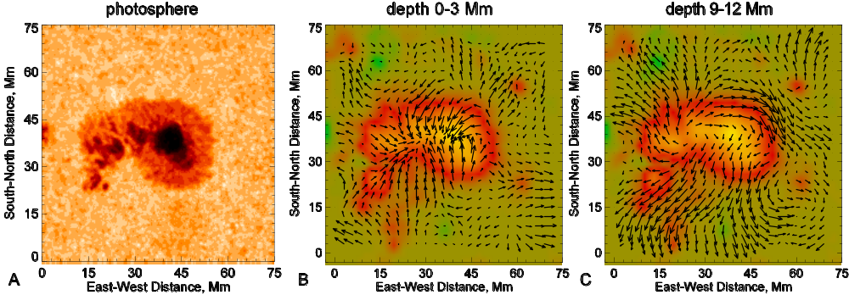
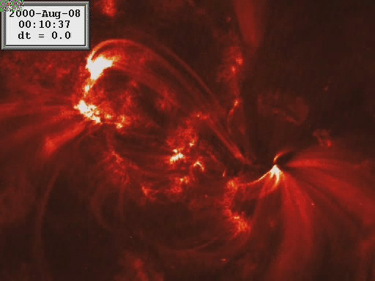
However, the dynamics in sunspot regions often is more complex. A new interesting phenomenon was discovered by analyzing flows associated with a rapidly rotating sunspot observed in August 2000 (Zhao et al, 2003). In this case, the main flow structure consists of two vortices, in the upper layers, 0—3 Mm, the plasma was rotating in the same direction as the sunspot structure at the surface, but in the deeper layers, 0—9 Mm, the plasma rotation was in the opposite direction. At this point it is unclear whether this flow pattern was generated by untwisting of emerging magnetic loops, or it was caused by the effects of magnetic fields on the large-scale near-surface convection. Resolving this problem is very important for understanding the processes of generation and ejection of magnetic helicity. Simultaneous observations from TRACE showed a spectacular twisting of magnetic loops in the corona and a mass ejection. Unfortunately, SOHO was not in the continuous contact during this event, and the data are rather fragmented. Thus, more high-resolution observations of sunspots are needed to study them at different stages of evolution and dynamics.

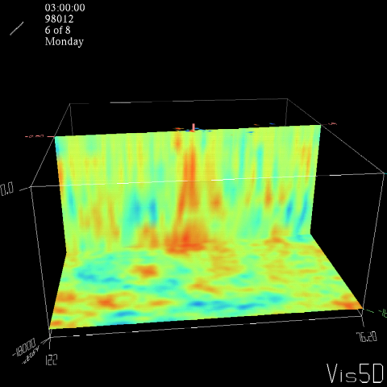
Emerging active regions. By a time-distance analysis of the MDI data, Kosovichev et al (2002a) have attempted to capture emerging active regions in the convection zone before they appear on the surface. The sound-speed images showed that the emerging flux propagates very rapidly in the upper 20 Mm, with a speed exceeding 1 km/s. This makes the earlier detection of emerging active regions difficult, and indicates that this will require mapping of the deep convection zone. Kosovichev et al (2002b) have also investigated the flow patterns associated with the emergence and evolution of a large active region, NOAA 9393, in March-May, 2001. They showed that there was no specific large-scale flow pattern prior the emergence. Once a significant portion of the magnetic flux appeared on the surface, they observed the formation of long-living converging downflows. In the decay phase, there is a tendency for diverging flows. The formation of this active region occurred during a significant period of its lifetime, and was accompanied by numerous emergence events in the upper convection zone. These results challenge the models of active regions as emerging large-scale Omega-loops breaking apart near the surface. The investigation of the life cycle of active regions is one of the principal priorities.

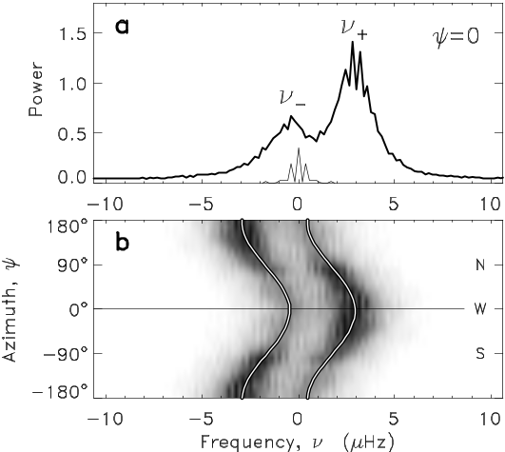
Supergranulation. The importance of supergranular flows for the distribution of solar magnetic flux and the formation of magnetic network is well known. By using long series (up to 9 days) of subsurface flow maps obtained from the MDI Dynamics data by time-distance helioseismology, Gizon et al (2003) have studied the global dynamics of the supergranular flow pattern. They concluded that it has a significant wave-like component that may explain the super fast rotation this pattern and also suppressed advection by the meridional flows. However, the physics of this phenomenon is not understood, and requires studying the details of the supergranular dynamics, both observationally and by numerical simulations. This is one the fundamental problems of solar physics and a great challenge.

